PE Funding

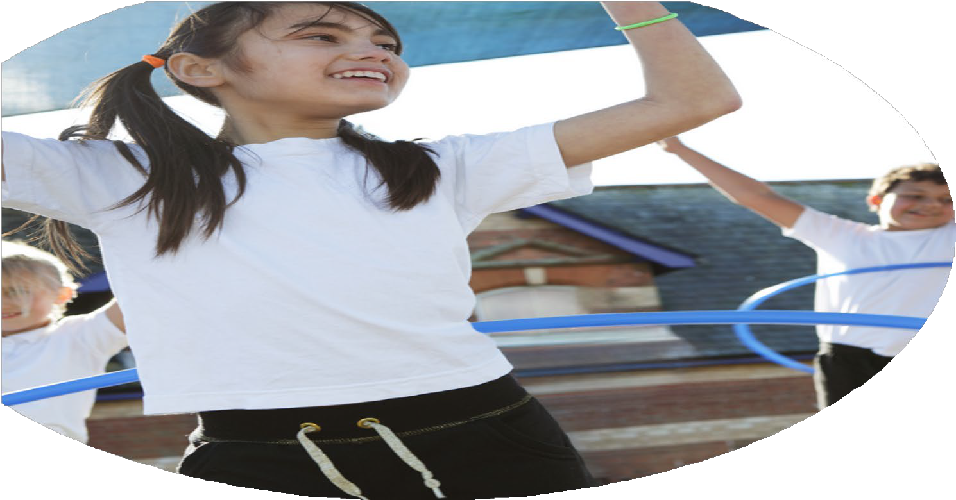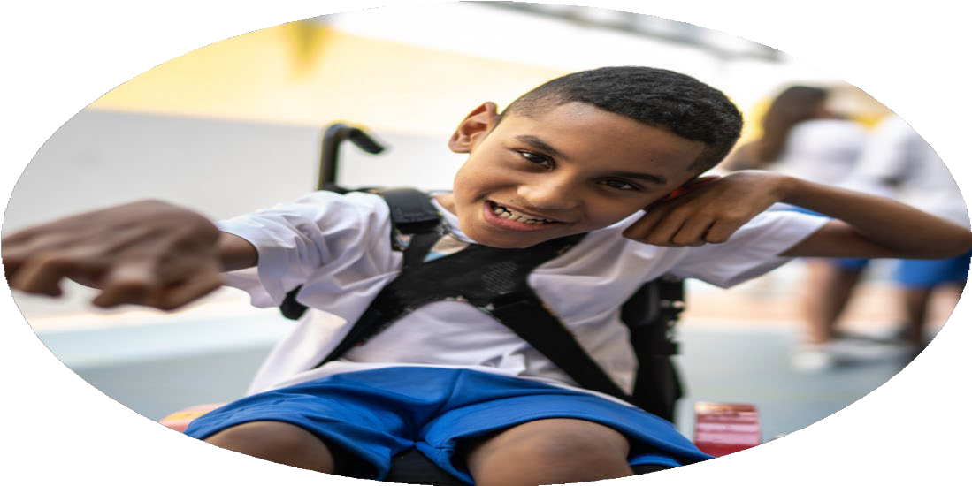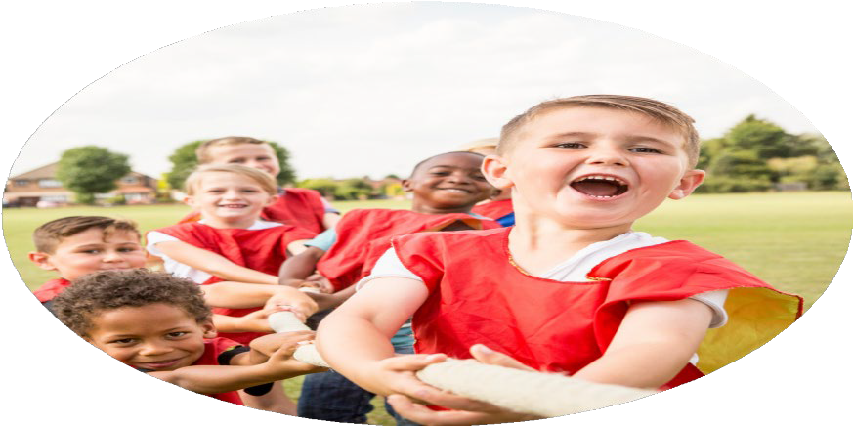

Evaluation Form

**Commissioned by**

**Created by**

Images courtesy of Youth Sport Trust

**PE Funding Evaluation Form**

 It is intended that this template should be used as preparation for the completion of the statutory digital reporting tool being introduced this academic year. You can upload data (including swimming) from this template onto this platform once it becomes accessible.

 Before you decide how you are going to use the funding for this academic year you should reflect and evaluate the impact of your use of the funding in 2023/24.

 All spending of the funding must conform with the terms outlined in the Conditions of Grant document.  The template is a working document that you can amend/update during the year.

 Based on your evaluation of last year’s funding you should decide what you intend to do this academic year, how you will do it, and what impact you expect it to have.

It is important that the funding is used effectively and based on your school’s needs.

 You must use the funding to make additional and sustainable improvements to the PE and sport in your school.  You must develop and add to the PESSPA activities that your school already offers.

*Summative digital reporting from June 2025 will continue to include swimming and water safety information therefore funding can be used to provide top-up lessons where necessary to ensure pupils meet national curriculum swimming requirements.*

**We recommend that you start by reflecting on the impact of current provision and reviewing your previous spend**

|  |  |  |  |
| --- | --- | --- | --- |
| What went well? | How do you know? | What didn’t go well? | How do you know? |
| Most children attended at least one sporting event during the course of the school year.  Teacher confidence in teaching PE and sports within school improved and high-quality lessons were accessed by all children each week.  A range of after school sports clubs were offered all year-round including rugby, cricket, football, rounders, running and athletics.  School swimming was provided on site meaning all children in year 4, 5 and 6 had lessons and 97% of children in Year 6 achieved NC standards in swimming. | Through registers of children attending. Pupil voice evidenced children’s keenness to take part in these activities. Very good behaviour and engagement observed at events.  Teacher and pupil feedback plus informal observations of lessons.  Levels of engagement in extra-curricular activities. Year 6 pupils led and coached football clubs under adult supervision.  Children’s confidence and enjoyment of the sessions. Very high levels of achievement within Year 6. Feedback from families. | The planned “Playground Play Leader” scheme.  Bikeability was offered but uptake was low.  Although most children did attend after school clubs, uptake was relatively low among older children, especially older girls. | Although children took part in training with enthusiasm, staffing changes meant that they were not given the opportunity to take up their roles as planned.  We have had discussions with the staff from the Schools Sports Partnership to improve uptake in the future. However, this is very dependent on the engagement of our families which is an ongoing barrier to many aspects of school life. Nest year we will send out more information to parents and hold assemblies in advance of the planned sessions to raise awareness among the children.  Plan more enrichment and sporting activities within the school day to ensure equality of access. |

|  |  |
| --- | --- |
| What are your plans for 2025/26? | How are you going to action and achieve these plans? |
| Intent | Implementation |
| 1. To promote active and healthy lifestyles and choices, prioritising the links between physical and mental wellbeing focusing on the importance of physical literacy. 2. To ensure all children access a range of different sporting activities including Forest School. 3. To continue to develop the school grounds to provide as many activities and healthy learning opportunities as possible. 4. To ensure all pupils achieve a good level of swimming skills and water safety skills. 5. Signpost pupils to local sporting offers to support participation outside school. | 1. Through the wider curriculum / focus days / enrichment activities built into the school timetable. 2. Two members of the team are not trained as Forest school practitioners. Forest School will be timetabled regularly for all Year groups from September. 3. The infrastructure for this will be funded through a grant that has been secured separately to PE Finding. However, its use and the way it is integrated into the Sports and PE curriculum overall is part of our wider strategy for developing healthy choices and sporting activities for all. 4. Swimming pool on site again to provide top-up lessons for all those who need it. Outcomes for children. 5. Sustainable links developed with local sporting offers – Park Run, local sports clubs, Community Centre etc. |

|  |  |
| --- | --- |
| What impact/intended impact/sustainability are you  expecting? | How will you know? What **evidence** do you have or  expect to have? |
| 1. Children of all ages, including older girls, are confidently taking part in a range of sporting activities. 2. Through skillful delivery of the PE curriculum, children continue to improve core skills which can be applied to a range of sports and activities. 3. Children have a better understanding of the importance of health and fitness and the links / crossover between physical and mental health. (Emotional Literacy) 4. Stronger links developed between the school and local sporting organisations. | 1. Levels of participation and engagement. 2. Feedback from visiting coaches and specialists. PE assessments. 3. Pupil’s choices about physical and mental health / lifestyles. 4. Children’s engagement in sporting and physical activities both within and without the school. |

|  |  |
| --- | --- |
| What **impact/sustainability** have you seen? | What **evidence** do you have? |
| 1. Greater interest in and confidence about taking part in sporting activities with children from other schools. 2. Teacher confidence in delivering the core PE curriculum. 3. Good outcomes in swimming ability. 4. Levels of pupil participation. | 1. Children’s attitudes to taking part / levels of engagement. 2. Lessons observations / teacher and pupils’ feedback. 3. Data from this year’s swimming lessons. 4. Children volunteering to take part in Park Runs, run clubs, train as playground leaders. |